Connor Cerisano, Mario Lavoie, Ayden Tucker
December 4 2020
COSC 2406 FA 2020
2D Side Scrolling Game – Lab Report

- Purpose
This lab was completed with the purpose of learning the basics of pygame, while also designing a moderately enjoyable and glitch-free 2D-side scrolling game. This was done to ensure thorough understanding of the course material of COSC 2406, as code from each lecture was required for the completion of the game. The use of group coding was greatly encouraged during this lab, to promote the growth and understanding of team coding. This lab was done in a fashion that taught time management skills and the skills of social management as well.

Features of typical 2D-side scrolling games that were taught in the lectures had to be implemented properly and smoothly. These features included: The illusion of movement with a sprite that stays in the center of the screen while the background moves, a jumping action that acted as a quadratic function of time, generation of random and spaced out targets, pictures that were to be imported as both background images and sprites for both the player avatar and the targets, a scoring and timer system, sprite mirroring, prevention of cheating and the termination of the game after a certain amount of time.

- OO-Analysis and Design – Describe the approach that your group took in planning, designing, implementing, and testing the game. As well, discuss how each of the specifications were implemented. Each specification will be thoroughly discussed and illustrated with pertinent code snippets.

Originally, the group consisted of two separate groups, each with their own planning process. The first group consisted of Connor Cerisano and Mario Lavoie, while the second consisted of Ayden Tucker and Matthew Fournier. In the first group, the planning process included using a program called Discord for meetings that involved working on the codebase and the creation of backgrounds. At the end of a meeting the next steps were discussed as well as a time to meet again to keep working on the codebase. The second group utilized the program Zoom for regular meetings on the progress that each group member made. At the ends of each meeting each group member was assigned their next step in order to make progress. The two groups were later merged, as Fournier left the course. In this new stage the now combined group continued planning on the program Discord, where roles were assigned and the project was worked upon piece by piece. Tasks were assigned to those based on who was the most confident in their ability to complete them.

In the beginning the two groups had codes consisting of two separate designs, that were combined into one based off the popular comic strip “Garfield” as well as a popular art forum on the platform Reddit called “r/ImSorryJon”. The design idea came from the original backgrounds of the second group, which are the ones seen in the final code. Originally neither of the groups had planned for a final design, as it was implemented after the merging of the two groups. The design only came to full fruition during the production of the avatar sprite.

While the two groups were still separate, they each produced their own form of the basic game. These two basic codes were combined, using the best aspects from each code. The final implementation of the actual sidescroller was a perfect mix between the two original codes with a rectangular avatar and the backgrounds from the second group, while the jumping code belonged to the first group.

## PLAYER JUMPING SYSTEM
## Calculate character's height as a function of time
AVATAR['height'] = 76 + (-time)*(time - 45)
## Ensure time will keep calculating until player hits ground
if (isJumping == False and keys[pygame.K_UP]):
isJumping = True
if (isJumping == True):
time = time + 1
DRAW = True
## Keep player on ground after a jump
if (AVATAR['height'] < 75):
time = 0
isJumping = False
AVATAR['height'] = 75

After that the two were merged and each person completed their respective tasks with assistance from the other group members. The Sprites for both the left and right facing avatar were blitted in the function called “drawAvatar” so that the sprite would move according to the original rectangle avatar. A second sprite was made up, and the source image for the avatar was replaced each time the left or right keys were pushed to complete the sprite mirroring.
def drawAvatar(avatar):
if (jonleft == True):
jonsprite['name'] = jonl
jonsprite['img'] = goingleft

if (jonleft == False):
jonsprite['name'] = jonr
jonsprite['img'] = goingright

win.blit(jonsprite['img'], (screenWidth/2 - int(avatar['width']/2),
398 - int(avatar['height']/2),
avatar['width'],
avatar['height']))
.
.
.
keys = pygame.key.get_pressed() ## Check input
if (keys[pygame.K_LEFT]):
player['x'] -= velocity
jonleft = True
movingForward = False ## Left is not forward.
elif (keys[pygame.K_RIGHT]):
player['x'] += velocity
jonleft = False
movingForward = True

The targets were designed and implemented in a way such that they will always appear at a random y value within a range and a set x value apart from each other. Their sprites were blitted in using a for loop for both convenience and lightness of code. Text was added using the .render() function for pygame.font.
win.blit(timerfont.render('Time: ' + str(ticks/1000), False, (0,0,0)), (20,10))
win.blit(myfont.render('Score = ' + str(s), False, (0,0,0)), (560,10))
The timer was added using the function pygame.time.get_ticks() in order to constantly count in milliseconds, while the time was displayed divided by one thousand in order to display in seconds. The score was implemented along with the collision detection, where an if statement checked the avatar’s x and y positions every loop in order to determine if the player was within a certain range of the targets.
for i in range(0, nTargets):
if (player['x'] < Target[i]['x'] + Target[i]['width'] and
player['x'] + jonsprite['width'] > Target[i]['x'] and
AVATAR['height'] < Target[i]['y'] + Target[i]['height'] and
AVATAR['height'] + jonsprite['height'] > Target[i]['y'] and
movingForward == True):
Target[i]['blit'] = False
Target[i]['score'] = True ## update score, cant be reused

Once within range the target ceases blitting and one point is awarded, then that specific target is locked so that no more points can be awarded from the invisible block. This also prevented cheating.
for i in range(0,nTargets):
if (Target[i]['blit']==True):
win.blit(Target[i]['img'], (Target[i]['x'] - camera['x'] + halfScreenWidth, Target[i]['y']))
if (Target[i]['score']==True and Target[i]['lock']==False):
s+=1
bonk()
Target[i]['score']=False
Target[i]['lock']=True

After the timer reaches 90 seconds, the game terminates using the pygame.quit() function.
if ((ticks/1000) >= 90):
print('game ended')
pygame.quit()

While testing, the python IDE was used, when there was an error the IDE showed that there was an error, gave the specific line that the error was on and gave a message relating to it. Using this feature in errors in the codebase were able to be corrected.

To work through some of the errors encountered while developing the sidescroller, debug features were created. These features helped in being able to display, troubleshoot, and determine the location of the player, the avatar representing the player, the camera, and finally the random location of all the targets. To display locations win.blit() was used. Using these debug features, collision detection was able to be improved upon by determining that the player’s y-coordinate was not changed when the player jumped. Instead, the avatar’s y-coordinate was responsible for determining the player’s y-location at any given time. Knowing each target’s randomized location also helped determine how accurate the collision was.
## DEBUG STUFF (feel free to remove this later)
debugfont = pygame.font.SysFont('Times New Roman', 17)
win.blit(debugfont.render('playerX = ' + str(player['x']), False, (0,0,0)), (10,70))
win.blit(debugfont.render('playerY = ' + str(player['y']), False, (0,0,0)), (10,90))
win.blit(debugfont.render('cameraX = ' + str(camera['x']), False, (0,0,0)), (10,110))
win.blit(debugfont.render('cameraY = ' + str(camera['y']), False, (0,0,0)), (10,130))
win.blit(debugfont.render('avatarWidth = ' + str(AVATAR['width']), False, (0,0,0)), (10,150))
win.blit(debugfont.render('avatarHeight = ' + str(AVATAR['height']), False, (0,0,0)), (10,170))
fontLocation = 50
for i in range(0, nTargets):
fontLocation = fontLocation + 20
win.blit(debugfont.render('target' + str(i) + 'X = ' + str(Target[i]['x']), False, (0,0,0)), (580,fontLocation))
fontLocation = fontLocation + 15
win.blit(debugfont.render('target' + str(i) + 'Y = ' + str(Target[i]['y']), False, (0,0,0)), (580,fontLocation))

Background music was added using the function pygame.mixer.music.load() and pygame.mixer.music.play() which makes the music play on loop. The music itself was made by the group mates who each had a part in creating the sounds. Lavoie used a guitar that went through a reverb pedal followed by a fuzz pedal and finally through an amplifier, a mic was used to record the amplifier and went to a soundcard so the digital audio workstation Cakewalk has the recording from the amplifier. Tucker was responsible for the accordion played throughout the background music. A short waltz was played on his Accordiana accordion using the chords C 6th minor, G minor and F major. Cerisano was responsible for mixing all of the sounds together to create a music track to play in the background of the game. Using video editing software, the sound effects were layered overtop each other and multiple effects like reverb and distortion were applied to each audio file to get the end result. The final music track was rendered and added into the game using the appropriate pygame music functionality. Sound effects were added into the game using the pygame.mixer.Sound.play() and the pygame.mixer.Sound() functions. These two pygame functions were placed into a custom function named bonk(), and this function is called every time the player scores a point. To be able to play the sound effect properly, it was discovered that the file has to be of the type “.wav”, and that “.mp3” files do not work when playing audio files.
musec = pygame.mixer.music.load('./Musac/lasagna time.wav')
pygame.mixer.music.play(-1)

def bonk():
pygame.mixer.Sound.play(pygame.mixer.Sound('./Musac/fart.wav'))

- Auxiliary tools used in addition to the Pygame engine. E.g. Imaging tools that were used to generate the background images.

Discord and zoom were used for planning meetings to work on the code as well as using these programs for the meetings. Gimp and FireAlpaca were used for the creation of sprites and backgrounds, they have the benefit of being free to download. Gimp was used for the creation of the target sprite as it has good features to make the desired square target, such as a rectangle select tool and a bucket fill tool. FireAlpaca was used to make the player sprite using the pen tool. The backgrounds were also made using FireAlpaca as it has drawing table integration, the tablet used to draw the backgrounds it the Wacom Intuos pen tablet. Github was used to share the codebase and the created assets with each member of the group. It proved to be a valuable tool also for version control as different branches could be made and merged to work on a particular part of the codebase separately. Version control also allowed the use of previous uploaded versions if a mistake was made on the newest version of the project. Google docs was used to work on the lab report component of the project. This way each group member can work on the report at the same time. Many tools were used for the recording and making of the music. One of these was the digital audio workstation Cakewalk which was used to record many sounds. For another recording software, HD Audio Recorder was used. To make the music and mix together all of the sounds, Vegas Pro 17.0 was used. Despite being a video editor, this program is a good alternative to any digital audio workstation and provides many sound effects that can be applied to any audio file. A youtube to mp3 site was used to get the sound effect for when the player collects a point.

- File I/O – Describe the file input/output mechanisms that were used for loading, reading, and displaying game assets.

To load, read, and display game assets, multiple pygame modules were used. After pygame.init() was called to initialize the pygame environment, pygame.mixer.music.load() was responsible for importing and playing the background music, and pygame.mixer.Sound() was used for playing the sound effect that plays when the player hits a target. To import images and sprites, pygame.image.load() was used. Each function mentioned takes in a string that specifies the file path to the game asset. To be able to display images correctly for the avatar and the targets, each corresponding dictionary has an img attribute that stores the image and relates it to the asset.

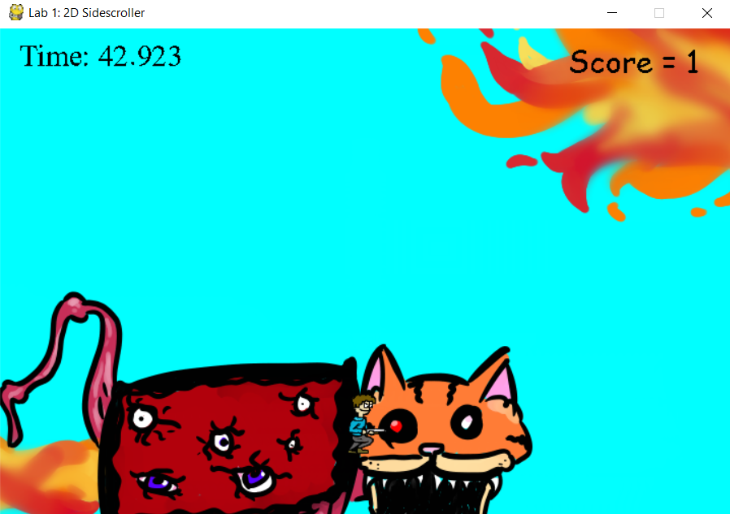
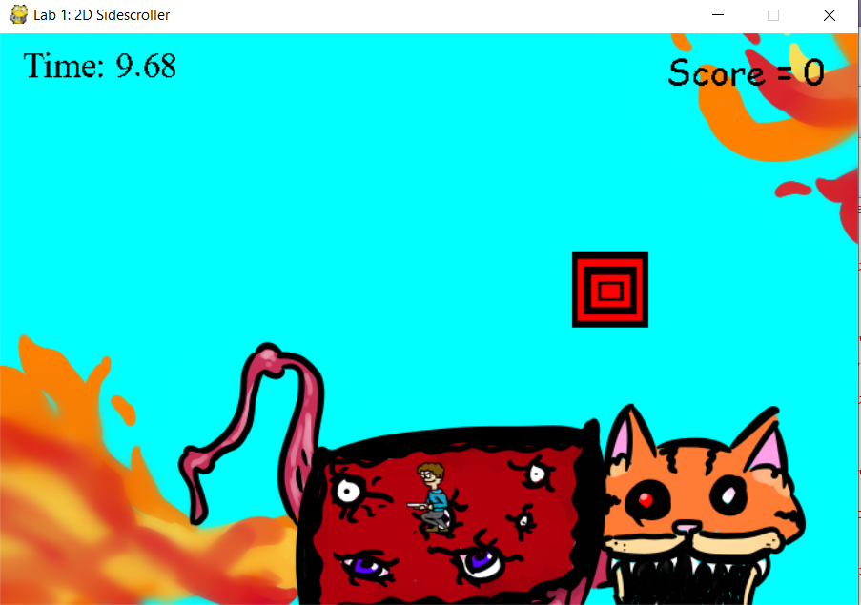
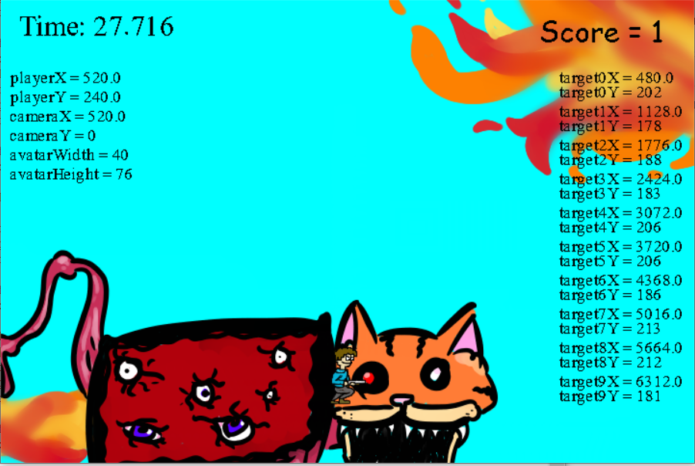
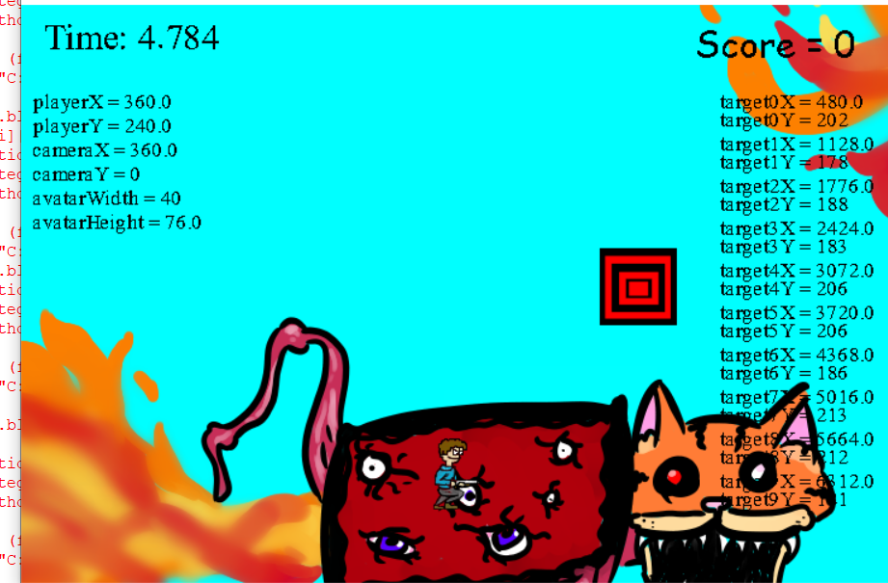
- Results
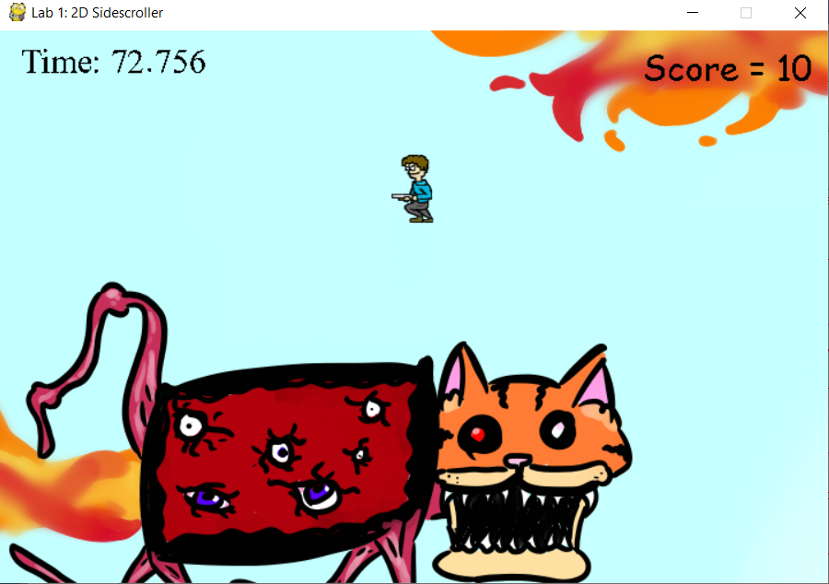
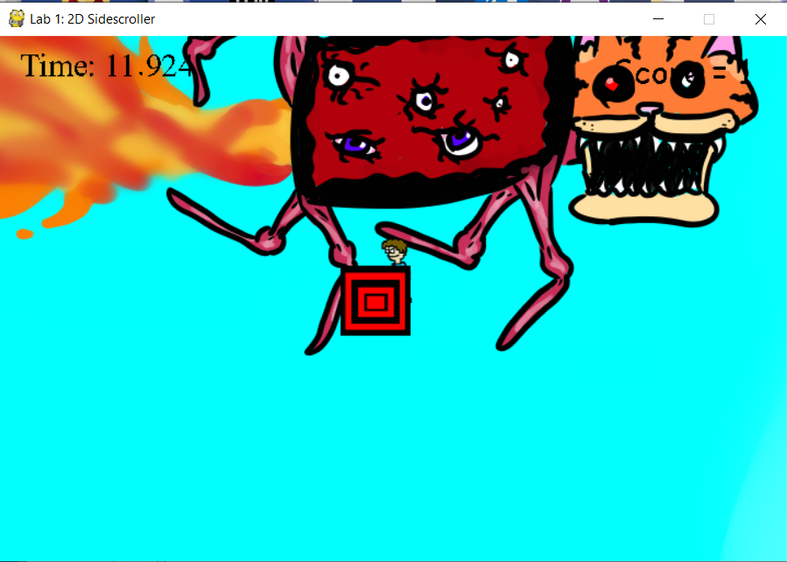
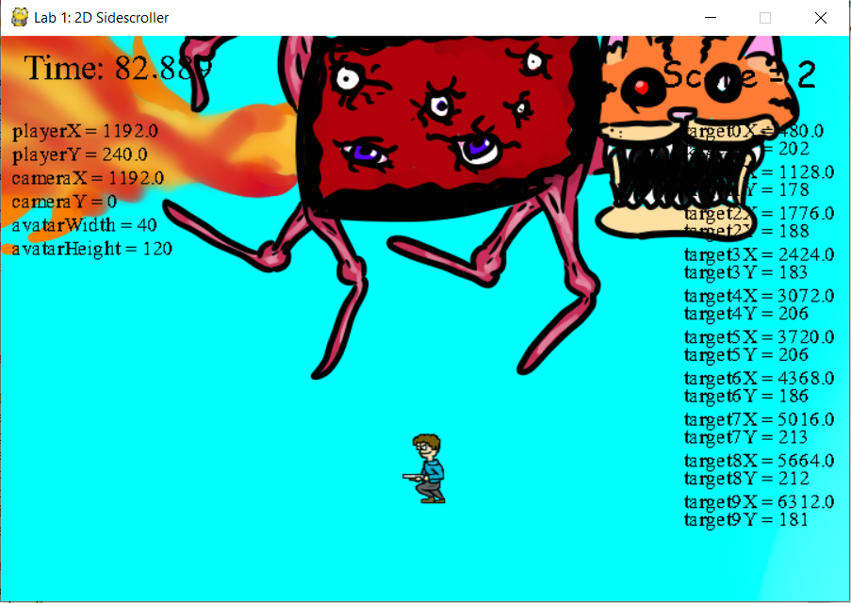
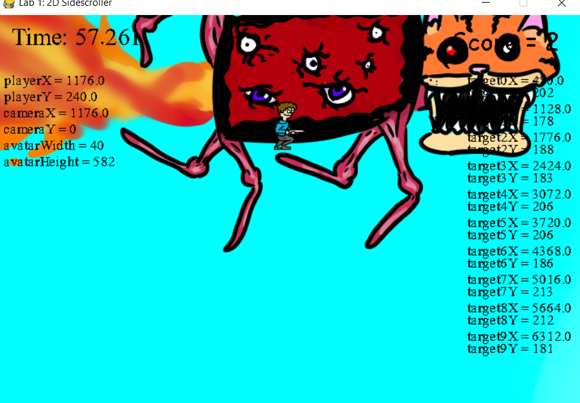

- Discussion of the Results
The first four screenshots are using some of the debug features while the last four are of the game proper. In the first screenshot the base game is loaded. A target can be seen in this screenshot. The targets were made using a for loop to make 10 targets. These targets had a spacing value that would space them apart evenly on the x axis. There y values were randomly generated for each target. The second screenshot see’s the disappearance of the first target and the accumulation of the first point. The algorithm to detect if a target is hit compares each the y and x value of the target with those of the player. If they are within a certain range, the same range where the player would be behind a target then there is collision. To make a target disappear however another condition needs to happen, this condition is that the player is facing forward. The third screenshot shows the player jumping. The jumping tries to simulate real world physics by using a quadratic equation. As a quadratic function rises till its maximum and then descends, using the roots we can set them so they are the start of the jump and the end. This way when the jump starts and ends the y value of the player will be 0. Appropriate roots were chosen so that when the time value or x value is 0 the y value is 0 and when the time value or x value is 45 the y value will also be 0. These roots were also chosen to make the maximum height of the player roughly two thirds of the screen. The fourth screenshot shows the player facing towards the left. The fifth screen capture shows the game not in the debug mode. The sixth screen capture shows once again the disappearance of the first target. The seventh screen capture shows that the player can not make the target disappear while jumping from underneath the target or from the left of it. The last screen capture shows that every point possible has been collected.

Although there is no screenshot, when the escape key is pressed or when the time reaches 90 seconds the game exits. Blitting was the base of the game, as each time the game loop cycled the images each blitted twice or more. Blitting overlays images on top of each other using the newer data from each loop. This allows animation to look smooth and for the player to be able to see when the character moves or interacts with an object. Clamping was also important to be able to blit the background properly and lock the camera to the position of the player, ensuring the player stays in the game world. Without it, either the player or the background would not be able to move.

- Conclusion

The purposes for which this lab was originally started were all completed in various stages as the development of the game progressed. The basics of pygame were learned gradually throughout the process of the coding, error checking and testing phases. Once the groups were adequately merged group coding became a normalized method that was used for approximately 2-4 hours every two days. This normalization of time constraints is what made the time management and social management skills grow along with the code. Each feature was able to be implemented smoothly as each group member was able to apply their expertise in each area they were assigned to. For the majority of the lab, the game’s ability to blit was hindered by the amount of blitting and update displaying that was being done, so the game was quite slow and glitchy. After some brief readjustments the game’s new smoothness became apparent. The jumping action was implemented in two separate ways originally and transferred into one function with minimal glitches. The targets, represented in a 2 dimensional space, took the longest time to add and perfect, undergoing many rigorous coding tests and rewrites. All pictures were able to be imported with relative ease, after they were created as one picture and split into ten. Sprite mirroring was able to be implemented with two sprites that flip depending on which keys are pressed. The text on the screen for the final game was added using two separate fonts, as it was thought it would make them more distinguishable. The prevention of cheating took a considerable amount of time, as coding it passed from one group member to another. The game properly terminated after 90 seconds is reached.

Many auxiliary tools were used in the creation of the game. These tools each may have many uses in the program but were used for a specific purpose. The purpose could be for communication between group members, creation of sprite assets, creation of music, working on the project at the same time and version control. All instances of file input in the game worked as expected, and each game asset was able to be read and displayed using the appropriate functionality.The results from the lab were a character that moves, jumps and can change direction, Targets with random y position and evenly spaced out x values. These targets can be collided with from the front to collect a point and make the target disappear. A timer was implemented and when it reached 90 seconds the game would close, the game can also close by hitting the escape key during gameplay.

- Bibliography, including properly referenced sources for any images.

Gaming Sound FX, 3rd of October, 2020, Reverb Fart - Sound Effect (HD), https://www.youtube.com/watch?v=1B0RQBH0LOw

Davis, J. (June 19 1978). Garfield. New york, New York, United States of America . Penguin Random House LLC.
-Used as inspiration for backgrounds and player avatar
Pygame Website¶. (n.d.). Retrieved December 03, 2020, from https://www.pygame.org/docs/
Contributors, MDN (2020, October 27). 2D collision detection. Retrieved December 03, 2020, from https://developer.mozilla.org/en-US/docs/Games/Techniques/2D_collision_detection

